CIS2520_SQL homework
Your Name
Chapter 7 DML Insert, Update, Delete (commit, rollback, savepoint) Commit all DML after you verify changes are correct.

- DJs on Demand just purchased four new CDs.
Use an explicit INSERT statement to add each CD to the d_cds table.
After completing the entries, execute a SELECT * statement to verify your work.

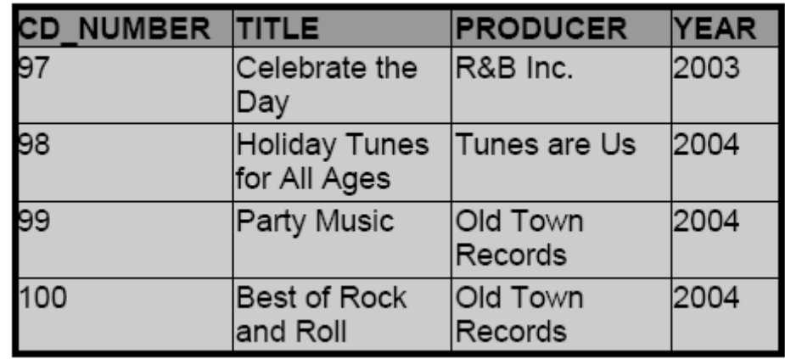
100
101
103
102
For Producer=R&B: You will have to use your pipes||
values(101, 'R'||'&'||'B', '2004')
insert into d_cds values (100, 'Celebrate The Day', 'R'||'&'||'B Inc.', 2003);
insert into d_cds values (101, 'Holiday Tunes for All Ages', 'Tunes are Us', 2004);
insert into d_cds values (102, 'Party Music', 'Old Town Records', 2004);
insert into d_cds values (103, 'Best of Rock and Roll', 'Old Town Records', 2004);
select * from d_cds;

- DJs on Demand has two new events coming up. One event is a fall football party and the other event is a sixties theme party. The DJs on Demand clients requested the songs shown in the table for their events. Add these songs to the d_songs table using an implicit INSERT statement.

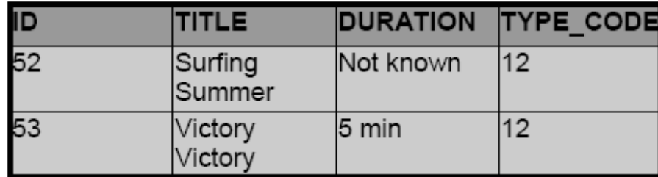

insert into d_songs (id, title, duration, type_code) values (52, 'Surfing Summer', 'Not known', 12);
insert into d_songs (id, title, duration, type_code) values (53, 'Victory Victory', '5 min', 12);
select * from d_songs;

- Add the two new clients to the d_clients table. Use either an implicit or an explicit INSERT.

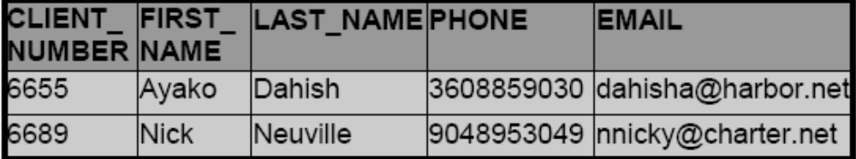
insert into d_clients values (6655, 'Ayako', 'Dahish', 3608859030, 'dahisha@harbot.net');
insert into d_clients values (6689, 'Nick', 'Neuville', 9048953049, 'nnicky@charter.net');
select * from d_clients;

- Add the new client's events to the d_events table. The cost of each event has not been determined use 0 for Cost.
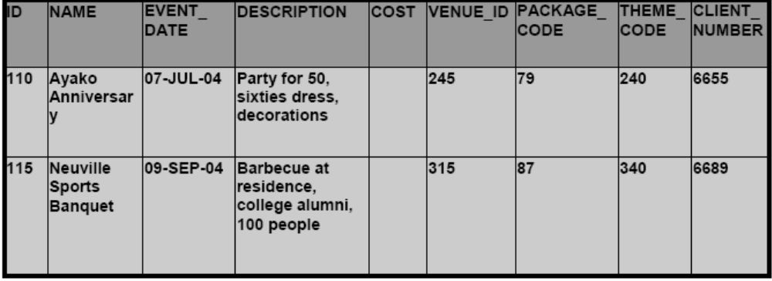
95
100
05
05
insert into d_events values (110, 'Ayako Anniversary', '07-JUL-04', 'Party for 50, sixties dress, decorations', 0, 95, 79, 240, 6655);
insert into d_events values (115, 'Neuville Sports Banquet', '09-SEP-04', 'Barbecue at residence, college alumni, 100 people', 0, 100, 87, 340, 6689);
select * from d_events;

5A. Create a table called rep_email using the following statement:(copy and paste in sqldev)

CREATE TABLE rep_email
(
ID NUMBER(4) CONSTRAINT REP_EMAIL_ID_PK PRIMARY KEY,
FIRST_NAME VARCHAR2(20),
LAST_NAME VARCHAR2(25),
JOB_ID VARCHAR2(15),
EMAIL_ADDRESS VARCHAR2(25) CONSTRAINT REP_EMAIL_ADDR_UK UNIQUE
);

5B. Populate the rep_email table above by running an INSERT SUBquery, only include the columns in the rep_email table above, Don’t forget to include a where statement to only include employees who are REPS (job_id)
insert into rep_email (id, first_name, last_name, job_id, email_address) (select employee_id, first_name, last_name, job_id, email from employees where job_id like '%REP');
select * from rep_email;

6. Monique Tuttle, the manager of Global Fast Foods, sent a memo requesting an immediate change in prices. The price for a strawberry shake will be raised from $3.59 to $3.75, and the price for fries will increase to $2.20. Make these changes to the f_food_items table.

update f_food_items set price = 3.75 where description = 'Strawberry Shake';
update f_food_items set price = 2.2 where description = 'Fries';
select * from f_food_items;

7. All employees at Global Fast Foods. Management has decided to reward them by increasing their overtime pay by .75 cents. Everyone will get an overtime_pay for your results. USE NVL.
Update the f_staffs table to show these new values. (Note: Some employees don’t get overtime pay. What function do you need to use to convert a null value to 0?)

update f_staffs set overtime_rate = nvl(overtime_rate + .75, 0);
select * from f_staffs;

8. Add the new customers shown below to the f_customers table.. Add all these records (3 Insert stmts)

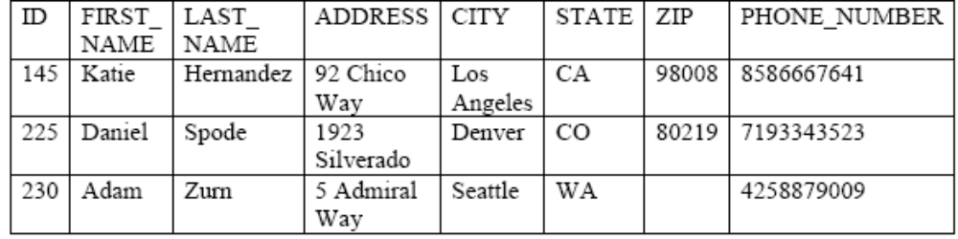
0
insert into f_customers values (145, 'Katie', 'Hernandez', '92 Chico Way', 'Los Angeles', 'CA', 98808, 8586667641);
insert into f_customers values (225, 'Daniel', 'Spode', '1923 Silverado', 'Denver', 'CO', 80219, 7193343523);
insert into f_customers values (230, 'Adam', 'Zurn', '5 Admiral Way', 'Seattle', 'WA', 0, 4258879009);
select * from f_customers;

9. Add the orders shown to the Global Fast Foods f_orders table: (3 Insert stmts)
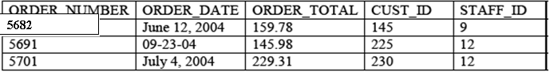

insert into f_orders values (5682, '12-JUN-04', 159.78, 145, 9);
insert into f_orders values (5691, '23-SEP-04', 145.98, 225, 12);
insert into f_orders values (5701, '4-JUL-04', 229.31, 230, 12);
select * from f_orders;

10. Sue Doe has been an outstanding Global Foods staff member and has been given a salary raise. She will now be paid the same as Bob Miller. Update her record in f_staffs. (subquery)

update f_staffs set salary = (select salary from f_staffs where last_name = 'Miller') where last_name = 'Doe';
select * from f_orders;

11. Global Fast Foods is expanding their staff. The manager, Monique Tuttle, has hired Kai Kim. Not all information is available at this time, but add the information shown at right.

ID | FIRST_NAME | LAST_NAME | BIRTHDATE | SALARY | STAFF YPE
25 | Kai | Kim | 3-NOV-88 | 6.75 | Order Taker

insert into f_staffs (id, first_name, last_name, birthdate, salary, staff_type) values (25, 'Kai', 'Kim', '3-NOV-88', 6.75, 'Order Taker');
select * from f_staffs;

12. Execute the following SQL statement. Explain in your own words what the error message is saying.
DELETE from departments
WHERE department_id = 60;

department_id has a primary key with a foreign key from the DEPARTMENTS table depending on it. First department_id from the departments table would need to be deleted to delete the one in the employees table.

13. Kim Kai has decided to go back to college and does not have the time to work and go to school.
Delete him from the Global Fast Foods staff.

delete from f_staffs where last_name = 'Kim';
select * from f_staffs;

14. Give all employees who are IT_PROG a 10% increase in Salary.

update employees set salary = salary + (salary * .10) where job_id = 'IT_PROG';
select salary from employees where job_id = 'IT_PROG';

